**Temperature change**

Global Warming, Temperature Change, Climate Change

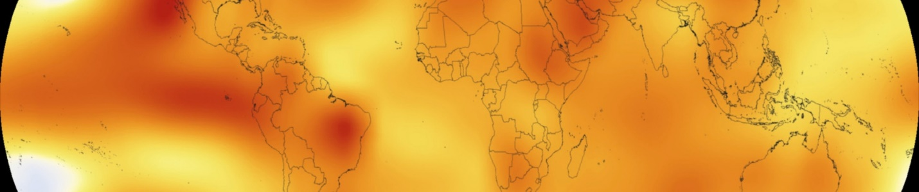

**Temperature change**

Data Card

Code (24)

Discussion (1)

arrow_drop_up213

**

more_vert

**About Dataset**

**Context**

Data description

The FAOSTAT Temperature Change domain disseminates statistics of mean surface temperature change by country, with annual updates. The current dissemination covers the period 1961–2019. Statistics are available for monthly, seasonal and annual mean temperature anomalies, i.e., temperature change with respect to a baseline climatology, corresponding to the period 1951–1980. The standard deviation of the temperature change of the baseline methodology is also available. Data are based on the publicly available GISTEMP data, the Global Surface Temperature Change data distributed by the National Aeronautics and Space Administration Goddard Institute for Space Studies (NASA-GISS).

**Content**

Statistical concepts and definitions

Statistical standards: Data in the Temperature Change domain are not an explicit SEEA variable. Nonetheless, country and regional calculations employ a definition of “Land area” consistent with SEEA Land Use definitions, specifically SEEA CF Table 5.11 “Land Use Classification” and SEEA AFF Table 4.8, “Physical asset account for land use.” The Temperature Change domain of the FAOSTAT Agri-Environmental Indicators section is compliant with the Framework for the Development of Environmental Statistics (FDES 2013), contributing to FDES Component 1: Environmental Conditions and Quality, Sub-component 1.1: Physical Conditions, Topic 1.1.1: Atmosphere, climate and weather, Core set/ Tier 1 statistics a.1.

Statistical unit: Countries and Territories.

Statistical population: Countries and Territories.

Reference area: Area of all the Countries and Territories of the world. In 2019: 190 countries and 37 other territorial entities.

Code - reference area: FAOSTAT, M49, ISO2 and ISO3 (<http://www.fao.org/faostat/en/#definitions)>. FAO Global Administrative Unit Layer (GAUL National level – reference year 2014. FAO Geospatial data repository GeoNetwork. Permanent address: [http://www.fao.org:80/geonetwork?uuid=f7e7adb0-88fd-11da-a88f-000d939bc5d8](http://www.fao.org/geonetwork?uuid=f7e7adb0-88fd-11da-a88f-000d939bc5d8).

Code - Number of countries/areas covered: In 2019: 190 countries and 37 other territorial entities.

Time coverage: 1961-2020

Periodicity: Monthly, Seasonal, Yearly

Base period: 1951-1980

Unit of Measure: Celsius degrees °C

Reference period: Months, Seasons, Meteorological year

**Acknowledgements**

Documentation on methodology: Details on the methodology can be accessed at the Related Documents section of the Temperature Change (ET) domain in the Agri-Environmental Indicators section of FAOSTAT.

Quality documentation: For more information on the methods, coverage, accuracy and limitations of the Temperature Change dataset please refer to the NASA GISTEMP website: <https://data.giss.nasa.gov/gistemp/>

Source: http://www.fao.org/faostat/en/#data/ET/metadata

**Inspiration**

Climate change is one of the important issues that face the world in this technological era. The best proof of this situation is the historical temperature change. You can investigate if any hope there is for stopping global warming :)

* Can you find any correlation between temperature change and any other variable?  
  (Using ISO3 codes for merging any other countries' data sets possible.)
* Prediction of temperature change: there is also an overall world temperature change in the country list as 'World'.